# STORY MODE – QUESTS

SIDE QUESTS

5. GET TREASURE FOR TOWNSFOLK

**REQUIREMENTS FOR QUEST:** TALK TO VILLAGER AND AGREE TO HELP THEM – Card Num. 5.

Effects after agreeing to it: White Karma Goes Up.

**LOCATION:** TOWN/ WILDERNESS – VILLAGE - CASTLE

**START:** Card num. 5 (Villager asks for help) > Yes > Go to Card Num.75

> No > End of Quest

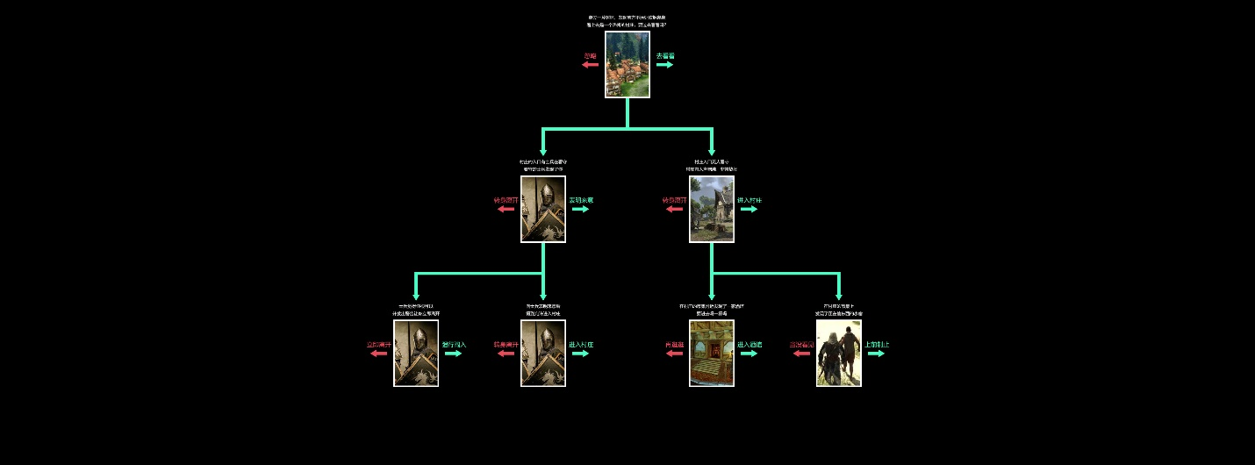

**ENDS IN: Town after succeeding in recovering treasure, in wilderness after taking treasure for yourself (Dark Karma Up), Death fighting bandits, etc.**

**POTENTIAL REWARDS AT FINISH:** White Karma Increases, X Golds, Health Reduced…

**CHANGES IN THE MAIN STORY-QUESTS:** No

**ORDER IN GENERAL STORYLINE:** Num. 5